NORFOLK COUNTY COUNCIL proposes to make a Temporary Traffic Order affecting the Wreningham FP3 from its junction with Wreningham FP4 for 156m north-westwards in the PARISH OF WRENINGHAM because of boardwalk construction works.

The footpath will be temporarily closed (except for access) from 4th to 29th October 2021 for the duration of the works expected to be about 26 days within the period.

Alternative route is via: Wreningham FP1, Hethel Road, Wreningham FP3.

(If necessary the restriction could run for a maximum period of 6 months from the date of the Order).

Penalty: £1000 maximum fine on conviction and/or endorsement for contravention.

In the event of the start date being delayed the new start date will be displayed on site in advance.

The person dealing with enquiries at Norfolk County Council is Harvey Woodyatt (Community and Environmental Services) Telephone 0344 800 8020.

Dated this 17th day of September 2021

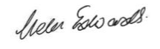

Helen Edwards

Chief Legal Officer

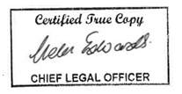

County Hall

Martineau Lane

Norwich

NR1 2DH

Map and plan of footpath closure and alternative diversion route