NORFOLK COUNTY COUNCIL has made a Temporary Traffic Order affecting the U78013 Wymondham Road from its junction with C129 Church Road for 582m westwards in the PARISH OF WRENINGHAM because of Anglian Water disconnection works.

The road will be temporarily closed (except for access) between 09:00 and 13:00 on 22nd November 2021 for the duration of the works expected to be about 4 hours within the period.

Alternative route is via: Wymondham Road, Bridge Road, Penny Green, Hethel Road, Church Road (Bracon Ash, Wymondham, Wreningham).

(If necessary the restriction could run for a maximum period of 18 months from the date of the Order).

Penalty: £1000 maximum fine on conviction and/or endorsement for contravention.

In the event of the start date being delayed the new start date will be displayed on site in advance.

The person dealing with enquiries at Norfolk County Council is Harvey Woodyatt (Community and Environmental Services) Telephone 0344 800 8020.

Dated this 19th day of November 2021

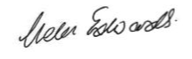

Helen Edwards

Chief Legal Officer

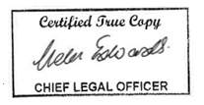

County Hall

Martineau Lane

Norwich

NR1 2DH

Map and plan of road closure and alternative diversion route